Comparison of Top IMAX

US markets (Wichita, KS and Moore, Okla.) to Nassau, BS

- Population
Nassau 248,948
Moore 56,397
Wichita 382,368

- Schools
Moore: 31 schools
- 3 high schools
- 5 junior high schools
- 22 elementary schools
Nassau: 214 schools (77,000 students)
Wichita: 294 (50,000 students)

- Population Density
New Providence 1,594 /km2
Moore 1,288.40/km2
Wichita 926.8/km²

- Population under 25
New Providence: 41%
Moore: 37%
Wichita: 37%

- Mean Income:
New Providence: $21,970
Moore: $23,378
Wichita: $23,878

- Disposable Income:
United States of America:
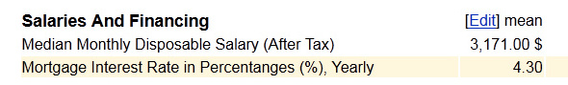
The Bahamas:
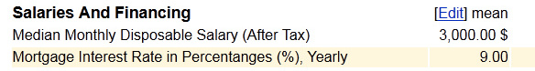

Sources:
US Census Bureau
CIA World Fact Book
World Bank
Numbeo Disposable Income Analysis

